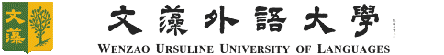
文藻外語大學 東南亞碩士學位學程
研究發現摘要
Research Findings Note

編號: RFN-__WANG__(Last Name)-_01(編碼方法請參藍字，提交時，依實際狀況繕打)___
研訪者姓名Name
學號Student No.
班級Year/Class
研訪國家Country
研訪時間Duration
研訪天數Days
累積天數 Accumulated Days
東南亞田野調查研究發現（研究問題、每日研究行程、具體研究發現並附至少三張研究照片）
Southeast Asia Field Research Findings (research question, daily research schedule, research findings and at least 3 research photos)
對日後想來該國/機構研訪的研究生建議 (如: 研訪行程安排注意事項、文化禁忌、健康注意事項等) Suggestions to other MSEAS students who plan to visit the same country or institutions (ex. tips for scheduling, cultural taboo, health recommendation, etc)
出訪證明（請提供護照入出境照片，以供計算累積天數）
Evidence of research duration (Please provide the photo of Entry Stamp, in order to count the accumulated days)

